# Task Engine One pager

An engine where it can create a task, track for task to complete then perform clean-up if required.

I have defined the sample interface definition.

Below snippets is written in c# but need to implement similar API’s in go.

Please follow test driven approach.

**Dependency graph**

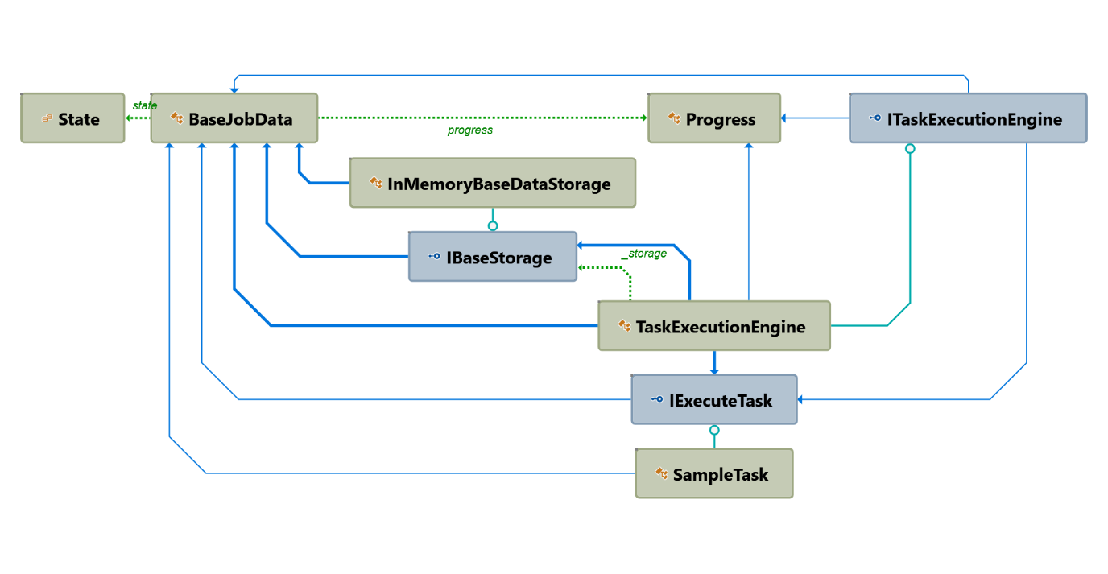

Need to implement TaskExecutionengine which contains below methods.

void StartTask(IExecuteTask task, BaseJobData baseJobDate);

Progress GetStatus(string id);

bool Cancel(string id);

bool Restart(string id);

StartTask will create a new thread and keep track of the thread and call IExecuteTask. ExecuteTask. will take two parameters

1. IExecuteTask – which implement the business logic.
2. BaseJobData – data which is used by IExecuteTask.

GetStatus will return the status of the job.

Cancel will cancel the job.

Restart will restart the job.